1. Parenthesis will prevent file-based routing

 This is called route group which help us organize our files without affecting URL structure

1. Nested layout structure

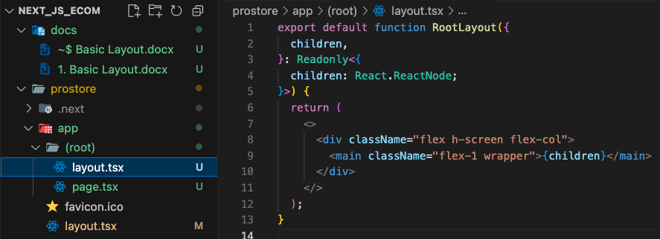

* We created a new layout and transferred our main page to the root group to use this layout.

1. Dynamic metadata

We added the template to use the DRY principle. We are taking everything from a constant file which is then taking from env file. The new URL is needed to create a valid URL.